For all of the banners I recommend putting the small phrase “Academic Network”

- Buttons that are used (Accept need to pop out more, use a fun pastel color. Refer to this article and show me different versions of the button that could work: http://www.1stwebdesigner.com/design/5-web-design-colours-visitors-click/
- In terms of positioning the bottoms in the right spot and making sure they are the appropriate size please refer to this article: http://www.smashingmagazine.com/2009/10/13/call-to-action-buttons-examples-and-best-practices/

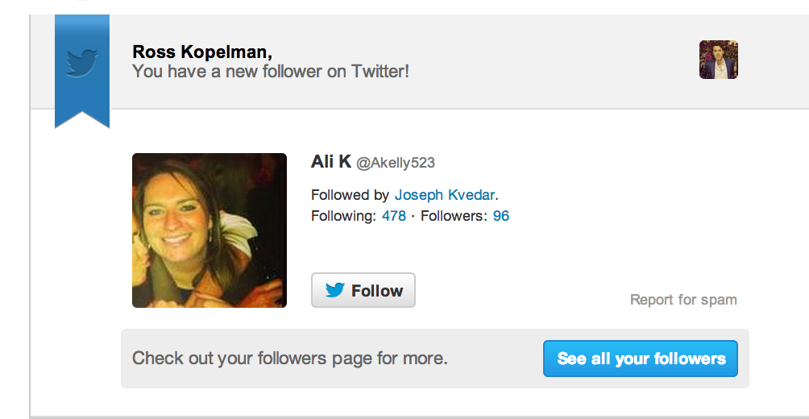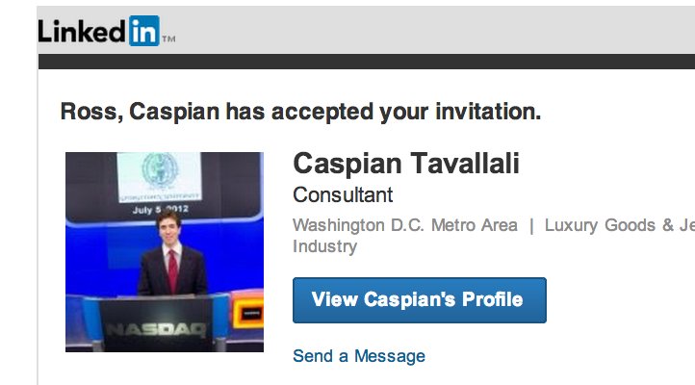

Notice the size of the logo vs the size of the call to action button for the emails above

- Reset Email needs to have the text from the google document with a button that says reset password.
- Make sure that the layouts for the emails are smooth. That we are using the text from the google document
- Improve the bottom size /position
- Make sure that the emails are optimized for mobile
- Add tag line “academic network”
- Size of logo vs size of button
- Color and position of botton
- Remove unscribe to this email instantly and change it to the following below
This email was sent to rosskopelman@gmail.com.
Don’t want activity notifications? Change your email preferences.
Have a question? Visit our Help Center.
©2013 Pinterest, Inc. | All Rights Reserved
Privacy Policy | Terms and Conditions

